FANTASTIC BEATS AND WHERE TO FIND THEM 3 MOVIE CAST, TRAILER, PLOT, AND REVIEW
DIRECTOR:
David Yates
RELEASE DATE:
July 15, 2022
TRAILER:
https://www.youtube.com/watch?v=n50rA_Jbfb4
CAST:
Jeremy Azis, Wilf Scolding, Sean Talo, Emilia Karlsson, Jude Law, Eddie Redmayne, Ezra Miller, Mads Mikkelsen, Katherine Waterston, Callum Turner, Dan Fogler, Richard Coyle, Poppy Corby-Tuech, Tony McCarthy, Jessica Williams, Victoria Yeates, Alison Sudol

PLOT:

The director stuns the audience by describing the Fantastic Beasts 3 in three words. He called the movie a prelude to World War II, which would imply that it takes place before September 1939. According to a recent interview with J.K. Rowling, she will be incorporating elements from Chinese mythology into the next film.
When Empire Film Podcast asks David Yates about Aurelius Dumbledore's place in the Dumbledore family tree, Yates replies, "At the beginning of Fantastic Beasts 3, we learn a little more about the family.

This movie is fantastic. Magic, horror, and romance abound in this story, which is plain entertaining." He also claimed to have given David Yates around two hours' worth of music along with a few brief comments.

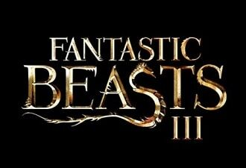

REVIEW:
As far as Wizarding World box office records go, The Crimes of Grindelwald ranked dead last. However, suppose Fantastic Beasts 3 is to be a success. In that case, it will have to overcome more significant obstacles since there are already so many Fantastic Beasts 3 debates out there that it may place an Avada Kedavra curse on the whole series.
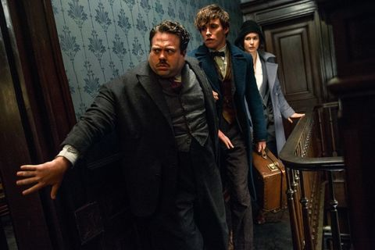
The choice of Korean actress Claudia Kim as Nagini was criticized for being inappropriate due to her race, and many people were disappointed. We know about the controversies around the film, but the third series of this film will give you goosebumps as per inside news.

