ETERNALS MOVIE REVIEW

DIRECTOR:
Chloe zhao

Cast:
Angelina jolie,Richrd Madden,Salma Hayek,Kit Herington,Gemma Chan,Kumail Nanjiani,Barry Keoghan,Brian Tyree Henry,Gil Barmingham,Lia McHugh and more.

RELEASE DATE:
November 5,2021

TRAILER: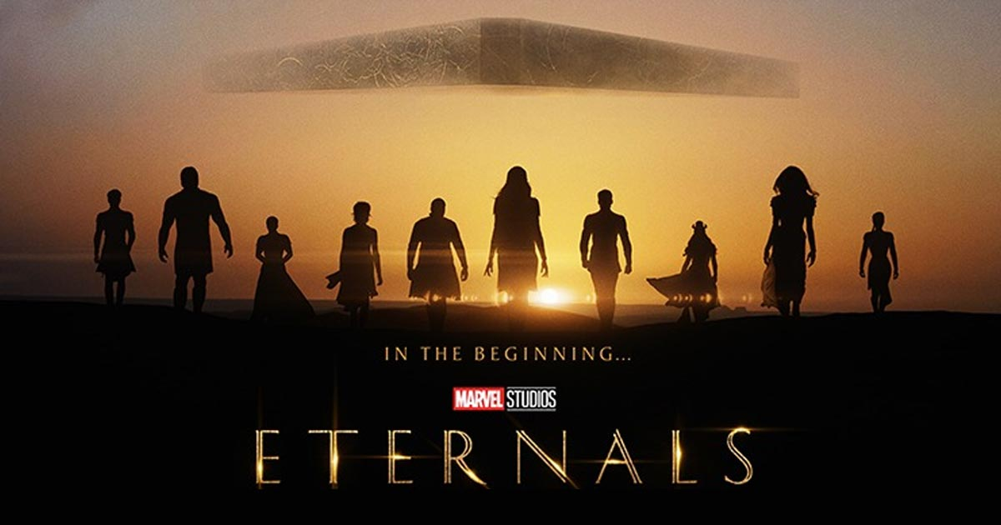

PLOT:
The Eternals is a fascinating reality of a comic mythos first dreamt by JACK KIRBY in 1970s: (as The Eternals share some similarities with DC’s New Gods, created by Kirby)
The Eternals are basically idealized humanoid alien ; genetically organized by the godlike Celestials. They were sent to the earth to protect and defend humanity from brutal Deviants. The Eternals have been keeping a watch on the earth for 70 years.

OVERVIEW:
The American superhero film Eternals is a story of two warring races ;The Eternals and The Deviants.The official synopsis describes Eternal as”ancient aliens who have been living on Earth for thousands of years.”
“Following the events of Avengers:Endgame,an unexpectected tragedy forces them out of the shadows to reunite against mankind’s most ancient enemy,The Deviants.”it reads.
The Eternals ;cosmic beings look perfectly human on outside but their advanced biology gives them astonishing energy,long lives and powers that ranks them far superior to the humans.The Deviants are the genetic cousins of The Eternals.Divergently to Eternals ;The deviants are hostile and hateful in nature.These two races have been engaged in a never-ending war since their early days and The Deviants sometimes practice their brutality on Humans as a revenge from The Eternals who are Humans’ lovers.
Marvel’s superpower heroes are incredibly appalling,with Thena(Angelina Jolie)handling sword made out of energy,Makkari(Lauren Ridloff)running at superfast speed,Ikaris(Richard Madden)blasting cosmic rays from his eyes and more.It appears that the characters in Eternals have immense possession of incredible powers which they manipulate for their defence as well as the humans.
The Eternals;though are not literally immortals yet they have much qualities of them as they heal fast,regenerate their limbs after cut off and above all ,they can only be slain after a long term planning and fight.
The peak point of the movie is the ill-will of the Deviants to dominate the earth ,ruining the humans.On the other hand the Eternals are fighting for the safety and survival of humanity as Thena proclaims,”We have loved these people since the day we arrived.When you love something you protect it”.
Another aspect of the story is the compassion of Kro with Thena.It seems possible,as in the comics,the two has the historical romance;Marvel has repeatedly claimed Eternals is a love story.As the trailer reveals the love triangle between Sersi,Black Night and Ikaris.It’s possible that the theme of love and romance also involves Kro and Thena.In the atmosphere of two warring races,this beam of love and tenderness gives us a hope of redemption.

