Legally Blonde 3 Movie , Cast, Trailer, Plot, and Review

DIRECTOR:
Jamie Suk

RELEASE DATE:
May 22, 2022
TRAILER:
https://www.youtube.com/watch?v=QNcRxCAteuw
CAST:
Jessica Cauffiel, Alanna Ubach, Reese Witherspoon, Jennifer Coolidge.
PLOT:
Amanda Brown is the author and creator of the Legally Blonde film series. American comedies, a Broadway musical, reality TV shows, and a cancelled series make up its bulk. The films follow Reese Witherspoon's Elle Woods, a California University of Los Angeles sorority president who decides to go to law school.
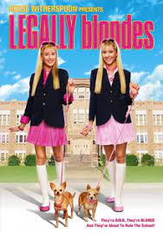

REVIEW:
I believe this is among the all-time greats. This has to be one of the most entertaining films I've ever watched. I'm sure I've watched it at least a dozen times, but it's been ten years since I last did. The Matrix trilogy is one of my favorite films. But everyone, at the absolute least, needs a pleasant, entertaining film that they can watch without working. In addition to being incredibly entertaining, I had no desire to pick up my phone and surf the web while watching it because it draws you in with great morals and fun yet excellent acting in a heartwarming story that I'm sure anybody could relate to, if not in the romantic sense but even more so for the struggle to make it through life and find meaning apart from Romance just doing what you love to do and being yourself.
This film is about being true to who you are, who you were intended to be by God, and not making excuses along the way.

