MORBIUS MOVIE CAST, TRAILER, PLOT, AND REVIEW

DIRECTOR:
Daniel Espinosa
RELEASE DATE:
the film will be released on January 28, 2022. You can watch this movie in your nearest cinema
TRAILER:
https://www.youtube.com/watch?v=jLMBLuGJTsA
CAST:
Adam El Hagar, Sam Wilkinson, Philip Gascoyne, Stuart Whelan, Bentley Kalu, Crystal Wingx, Adam Collins, Tina Louise Owens, Deborah Rock, Ria Fend, Dave Simon, Jag Patel, Jorge Leon Martinez, Nick Owenford, Pierre Bergman

PLOT:
To heal himself of an unusual blood disorder, biochemist Michael Morbius accidentally infects himself with vampirism.
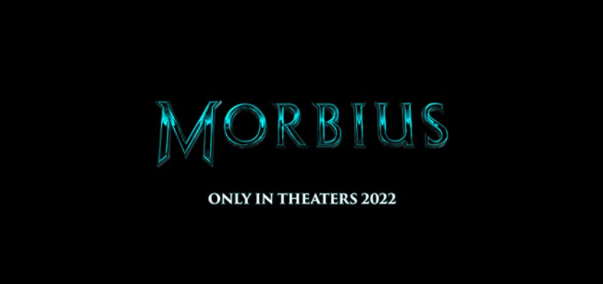

REVIEW:
Mobius is a horror-based action film that will be releasing on 21 January 2022. This film has various characters, but this film revolves around a person, a biochemist trying to cure himself of a blood disease. This movie starts with an action scene. But afterward, it turns into horror, and we can enjoy the suspense scenes as well.

