SCREAM MOVIE CAST, TRAILER, PLOT, AND REVIEW
DIRECTOR:
Matt Bettinellli-Olpin, Tyler Gillett
RELEASE DATE:
The film will be released 13 Jan 2022 (Nationwide).
TRAILER:
https://www.youtube.com/watch?v=xERJDUXsUTM

CAST:
David Arquette , Roger L. Jackson, Neve Campbell , Courteney Cox, Melissa Barrera, Jack Quaid, Marley Shelton, Dylan Minnette, Jenna Ortega, Mikey Madison, Kyle Gallner, Jasmin Savoy Brown, Mason Gooding, Sonia Ben Ammar
PLOT:
The plot revolves around Sidney Prescot, a man who stumbles across a string of murders committed by a mysterious masked serial murderer. Matt Bettunelli Olpin and Tyler Gillett are directing the film, which Kevin Williamson, the man behind the Scream horror series, is also executive producing. The masked assailant has been stalking us for more than two decades, and now it's returned to do it again.
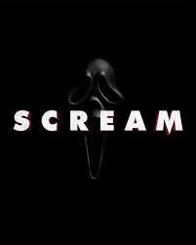
REVIEW:
It's difficult to predict the film's summary because of the secrecy surrounding the complete cast lineups. Official Scream 2022 plot details have been released, but they don't provide many cues as to what will really happen in the film. According to the official description, "A young lady returns to her former village only to discover terrible murder cases linked to a renowned masked serial killer."
This means that when Sidney returns to her hometown, she'll discover the horrors that the hooded villain has unleashed there. How long does she have left? And since she won't be the only one dealing with the masked serial murderer, the other actors will become involved in various ways, and we'll have to find out and watch when the movie comes out. Keep the anticipation high till then!

