Doctor Strange in the Multiverse of Madness MOVIE, CAST, TRAILER, PLOT, AND REVIEW

DIRECTOR:
Sam Raimi
RELEASE DATE:
The film will be released on March 25, 2022 (USA).
TRAILER:
https://www.youtube.com/watch?v=IzgofMFMHH4
CAST:
Swaylee Loughnane, Chiwetel Ejiofor, Benedict Wong, Bruce Campbell, Rachel McAdams, Xochitl Gomez, Tom Hiddleston, Benedict Cumberbatch, Elizabeth Olsen, Sam Raimi.
PLOT:
Even though an unofficial synopsis releases but it leaves additional questions unanswered. Here's what it says in plain language:
"Stephen Strange's investigation into the Time Stone continues after the conclusion of Avengers: Infinity War. However, an old friend turned foe puts a stop to Strange's schemes and forces him to unleash unimaginable horror."
Wanda may be the "old friend-turned-enemy," although she and Strange have had minimal on-screen contact in the films.
The section about "unspeakable wickedness" is a little more challenging to understand. Doctor Strange 2's main antagonist is still a mystery. Someone with connections to the multiverse is behind it. Does Mephisto have a plan? Was he called Kang the Conqueror by his opponents? And who knows, maybe it may be the Scarlet Witch herself!
It's doubtful that Kang will appear in Doctor Strange 2, So, there are plenty of options left. After all, Strange's adversaries in the comics are many, and any of them might appear in the film.
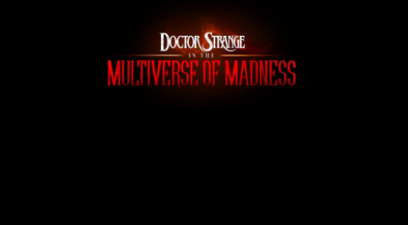
Wanda's journey in the film is more predetermined. We could tell from the ending of her video game that she wished to locate her children. Although the children were technically incorrect, she still loves them and fervently wants their return. As a result, she might unintentionally turn out to be the villain.
After she finished filming WandaVision, Elizabeth Olsen had no idea what Wanda would be doing in Doctor Strange 2, just as we all did. She also told Collider that the screenplay was continuously changing during shooting, which she shared with them.

