Mission: Impossible 7 MOVIE, CAST,TRAILER,PLOT,AND REVIEW

DIRECTOR:
Christopher McQuarrie
RELEASE DATE:
The film will be released on September 30,2022(USA). You can watch this movie in your nearest cinema.
TRAILER:
https://www.youtube.com/watch?v=ricB3NqtC04
CAST:
Lampros Kalfuntzos, Swaylee Loughnane, Mark Gatiss, Nico Toffoli, Charles Parnell, Shea Whigham, Rob Delaney, Cary Elwes, Indira Varma, Frederick Schmidt, Angela Bassett, Esai Morales, Henry Czerny, Nicholas Hoult, Ving Rhames, Simon Pegg, Pom Klementieff, Rebecca Ferguson, Vanessa Kirby, Hayley Atwell, Tom Cruise.
PLOT:
British action and espionage thriller Mission Impossible 7 directed and written by Christopher McQuarrie. Ghost Protocol is Christopher McQuarrie's third Mission Impossible film.
A train careens over a cliff and into a quarry in this movie, much as in the forthcoming Mission: Impossible film. This fantastic scene was filmed on Friday in Stoney Middleton
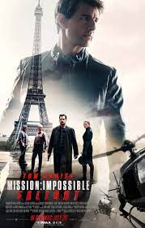

REVIEW:
This movie manages to raise the ante in action compared to prior installments, which is impressive. The number of car chases is much fewer than in previous episodes, and the combat is more visceral, with punches that seem like they hurt. Blood isn't uncommon for gunfights or savage stabbings, but (typical for these movies). Despite its almost two-and-a-half-hour running length, the picture maintains its lighthearted tone. However, there's not much to be concerned about in terms of sex or drug usage material. As long as the good men are ready to sacrifice themselves for the sake of others, characters like Ethan Hunt (Cruise) will remain stand-up people in a world full of treachery.

