Is Personal Jurisdiction an Obstacle in Achieving Substantial Justice? Court Rules Otherwise while Allowing the Appeal of Dietary Supplements maker Curry
Or
Personal Jurisdiction not a ‘Red Tape’ Standing between the Litigant and Justice
Mr. Charles Curry (“Plaintiff”) was running a business of selling dietary supplements under the trade name “Get Diesel Nutrition” since 2005. He was the founder and the CEO of the company having its place of business in the state of Illinois. He stated that the word “Diesel” was the heart of the trade name as it was used in almost all of its products like Diesel Test, and also that it was used in its website. In around 2016, Revolution Laboratories, LLC (“Defendants”) began selling a similar sports nutrient supplement under the brand name “Diesel Test Red Series, All-Natural Testosterone Booster”. The plaintiff filed a suit in the United States District Court for the Northern District of Illinois, Eastern Division (“District Court”) alleging that the packaging to the Defendants was in red and white and the text was slanted towards the right which was similar to that of Plaintiff’s, which created confusion among the consumers. The Plaintiffs also filed multiple allegations of trademark dilution, false advertising, etc. Revolution on the other hand, moved motion contending lack of personal jurisdiction as their place of business was neither in Illinois nor had any business operation extended to the state of Illinois. It was pointed out by Mr. Curry that Revolution’s interactive website had the option to ship the product to Illinois and it was in fact presented before the court that Revolution actually delivered its products in Illinois. The District Court pronounced its order in favour of Revolution and granted the motion to dismiss on the ground of lack of personal jurisdiction. Aggrieved by such ruling, Mr. Curry preferred an appeal in the United States Court of Appeals for the Seventh Circuit (“Appellant Court”) (Curry v. Revolution Labs, 949 F.3d 385 (7th Cir. 2020)) After in-depth analysis of all factors that was to be taken into consideration, it was held that Mr. Curry had shown a prima facie case of specific Personal Jurisdiction over Revolution and hence, it overruled the decision of the lower court and remanded the case back to the lower court for considering the case on merits.
Revolution sold its products entirely from online platform and had no physical presence. Before filing the case in the district court, the plaintiff in November 2016 had sent the Defendant a cease-and-desist letter. Subsequent to that, Revolution applied for trademark registration for “Diesel Test” mark for dietary supplements. Soon thereafter, Mr. Curry also applied for trademark registration of “Diesel Test” and contended to be the prior user of the same. The USPTO suspended both the applications on the ground of being similar and creating confusion in the minds of the consumers.
Mr. Curry thereafter approached the District Court, claiming the following:
- That the act of the Defendant had violated the Illinois Consumer Fraud and Deceptive Practices Act
- It also violated Lanham Act with respect to trademark infringement, false designation of origin and false advertising, trademark dilution by Tarnishment, and cybersquatting.
- The act also violated common law.
The Defendants Revolution moved a motion contending that there is lack of personal jurisdiction of the court on the Defendants. The Defendants had put-forth the following facts to establish the same. It stated that:
- Neither their place of business is Illinois nor do they have any agent in the state of Illinois.
- They do not even possess a telephone number/ mailing address in Illinois.
- It has no employees dedicated to extend business in Illinois nor does it have any employees who had ever travel to Illinois for business purposes.
- The business of Revolution has no property in Illinois.
- They had neither participated in any trade-shows nor conducted any business meeting in Illinois.
On the other hand, Mr. Curry showed evidences to prove the stand that even if Revolution did not have any physical presence, it did have business that extended to Illinois. Mr. Curry presented before the court that the website through which Revolution sold its Diesel Test products had the option to deliver the products to Illinois. Not only that, Revolution in fact served to at least 767 people in Illinois with its product and also have sent messages like "Thank you again for your business" after the shipping was made. To counter this stance, Revolution stated that the sales that it made to Illinois is very minimal and form only 1.8% of the total sales.
The District Court dismissed the suit on the ground of lack of personal jurisdiction upon the Defendants at a preliminary stage without any hearing. Aggrieved by such an order, Mr. Curry preferred an appeal in the United States Court of Appeals for the Seventh Circuit.
With respect to the issue of specific personal jurisdiction, the appellant court considered various Supreme Court precedents and thereafter laid down the essentials for exercising such jurisdiction on Defendants. Such essentials must be met and proved by Mr. Curry to establish a prima facie case. The court stated that: -
- Defendant must have purposefully availed itself to conduct business in the state of Illinois.
While dealing with this essential, the court very outrightly stated that personal jurisdiction is not dependant upon having any physical presence in the forum state. It stated that in absence of such physical business, it must be proved that the Defendants conducted such lawsuit related activities purposefully in the forum state aka Illinois. The court relied on the case of Illinois v. Hemi Grp. LLC, 622 F.3d 754, 757-58 (7th Cir. 2010) where it was held that court had personal jurisdiction over the cigarette seller who sold its products through online website to the residents of Illinois knowingly. Considering the facts presented by Mr. Curry relating to deliveries made to the residents of Illinois and subsequent thanking you message from Revolution, sufficiently satisfies the first essential of purposeful availment. Revolution very well knew and was aware that its products are being sold to Illinois’s residents.

- The plaintiff’s injuries must have arisen from the Defendant’s activities in the forum state.
While dealing with this essential, the court recognized and observed that Revolution’s product “Diesel Test Red” were directly sold in Illinois, which amounted to infringement of Mr. Curry’s rights over Diesel Test. Mr. Curry also pointed out that due to the Defendant’s sales, it created confusion among the consumers and thereby established in the court that prima facie the injuries caused to the plaintiff were due to the sales of Revolution in Illinois.

- Such exercise of personal jurisdiction should not compromise on fair play and substantial justice.
While dealing with this essential, the appellant court was of the opinion that exercising personal jurisdiction over the Defendants would not be a compromise on fair play and substantial justice. It pointed out that Revolution held itself out as doing business nationwide through its own and third-party websites. Also, the burden on Revolution to defend itself in Illinois was minimal. Hence, even the third essential was met.

Accordingly, the appellant court, overruled the decision of the lower court and remanded the case back to the lower court for considering the case on merits recognizing specific personal jurisdiction over the Defendants.

Curry v. Revolution Labs, 949 F.3d 385 (7th Cir. 2020)

Image to be Used:
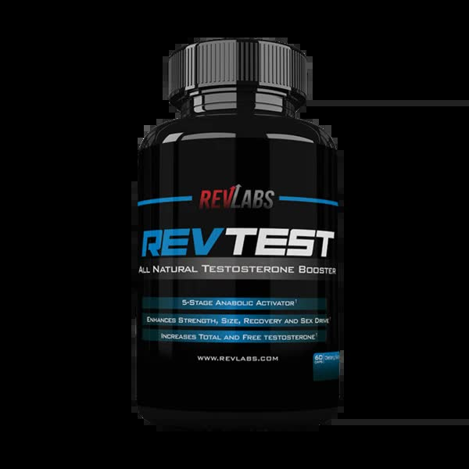

Image source: https://revlabs.com/search?q=testosterone+booster

