Use of Trademark on Counterfeit Products? No Requirement for “Wilful Infringement”, Rules Supreme Court
Or
Wilful Infringement not a Mandatory Requirement for Recovering an Award for Profit, Rules US Supreme Court

Romag Fasteners, Inc. is an American company involved in manufacturing magnetic accessory & products such as snaps, clasps, fasteners, closures, etc. With its production and distribution centres located in the U.S, Europe, and Asia, the company is known internationally for its signature product - the magnetic fastening snap. Fossil Group, Inc. ("Fossil, Inc.") is a global design, marketing, distribution, and innovation company involved in manufacturing distinctive watches and wearable accessories such as leather goods, belts, handbags, sunglasses, etc. As part of one of their business ventures, the companies entered into an agreement wherein Romag's fasteners were to be used in Fossil's leather goods. While both the companies were content with the arrangement for an initial couple of years, it was eventually discovered by Romag that several Fossil products made in China were using counterfeit Romag fasteners. In an attempt to save its business, Romag sued Fossil, along with several of its retailers, for trademark infringement pursuant to 15 U. S. C. §1125(a) in the United States District Court for the District of Connecticut (“District Court”). While during the trial, the jury agreed with Romag in the act of Fossil being in callous regard, the accusation of "wilful act" was duly rejected. Aggrieved by the decision, Romag moved to the United States Court of Appeals for the Federal Circuit ("Federal Circuit") (Romag Fasteners, Inc. v. Fossil, Inc., 817 F.3d 782, 791 (Fed. Cir. 2016)).The Federal Circuit decided wilfulness as a precondition when it came to disgorging profits following the Second Circuit precedent of George Basch (George Basch Co. v. Blue Coral, Inc., 968 F.2d 1532, 1537 (2d Cir. 1992)). When finally brought before the Supreme Court in 2020 (Romag Fasteners, Inc. v Fossil Group Inc. 140 S.Ct. 1492 (2020)), the Court, in a unanimous opinion, shot down the requirement of "wilful" infringement in regard to recovering an award of profits.

Invented in 1997, Romag magnetic snaps were advanced patented designs used to secure snaps and closures without the assistance of a latch or any other moving mechanism. Fossil Inc., in 2002, signed with Romag an agreement that would let them use Romag's patented snap fasteners, as well as the Romag trademark in their handbags and other products. While the companies were content with the agreement initially, it was discovered by Romag in 2010 that some of the factories hired by Fossil in China to make its products were involved in using counterfeit Romag fasteners. Unable to resolve the dispute amicably, Romag sued Fossil Inc. and their retailers Macy's Inc., and Macy's Retail Holdings, Inc. (collectively, Fossil) for patent & trademark infringement pursuant to 15 U. S. C. §1125(a) in the District of Connecticut, where the case proceeded for trial.

After duly hearing the parties, the U.S. District Court for the District of Connecticut granted a temporary restraining order against Fossil on the sale of the alleged products. However, the court rejected Romag's request for an award of profits. This was because, although it had been found that Fossil had acted callously, Romag's accusation of the act being a wilful one had been rejected by them. The wilfulness of the act played a crucial role in the case as, while suing Fossil for trademark violation, Romag had also sought (among other things) the share of profits it earned during the period of violation. However, as per a Second Circuit precedent, a "wilful" violation on behalf of the defendant is a determining factor in deciding cases of profit awards.

After being heard in the Federal Circuit that upheld the decision of the District Court, the Supreme Court considered the matter on 14th January 2020 for arguments. Romag argued that the plain text of the Lanham statute only requires a violation of §1125(a) when it comes to allowing an award of profits, which was countered by Fossil stating that a profits award is an equitable remedy that has factored the requirement of wilful finding for over a century.

After duly considering the claims of both the parties, Justice Gorush, observed that, although §1117(a) of the Lanham Act portrays wilfulness as a requirement to a profits award in a suit under §1125(c), it was never a requirement under §1125(a). The court also pointed out that reading words into the statute must be avoided, considering they have been specified elsewhere in the very same statute. The absence of the provision in a statute showing due consideration for mental states was considered self-explanatory by the court. Further, regarding Fossil's counter-argument on how §1117(a) 's language indicates that a violation under §1125(a) triggers an award of the defendant's profits subject to the principles of equity, along with the history of equity courts that has factored in the concept of wilfulness while deciding on similar matters, the Court observed that equity courts did not decide as much on patent infringement and other analogous cases at the time (See, e.g., Dowagiac Mfg. Co. v. Minnesota Moline Plow Co., 235 U. S. 641, 644, 650–651 (1915)). It was also noted that accepting the said argument put forth by Fossil would mean assuming the Congress intended to incorporate the requirement of wilfulness obliquely in the said area, while it has expressly added the mens rea factor elsewhere in the statute. The court also observed that several cases before the statute and some after the statute did consider wilfulness as a prerequisite for profits-award suits and rarely authorized profits for purely good-faith infringements. However, although the court recognizes the traditional practices of inclusion of the defendant's mental state in determining the applicability of an award of profits, it was concluded that the same was a far cry for the case at hand.

The court thereby concluded via the opinion of Justice Gorush that a plaintiff in a trademark infringement suit is not required to show that the defendant wilfully infringed their trademark as a precondition to receiving a profits award. The opinion that was backed by seven other Justices of the court recognized the importance of the concept of wilfulness but was of the view that the same was not an absolute precondition, thereby vacating the case for further proceedings.

Romag Fasteners, Inc. v Fossil Group Inc. 140 S.Ct. 1492 (2020)

Image to be used:
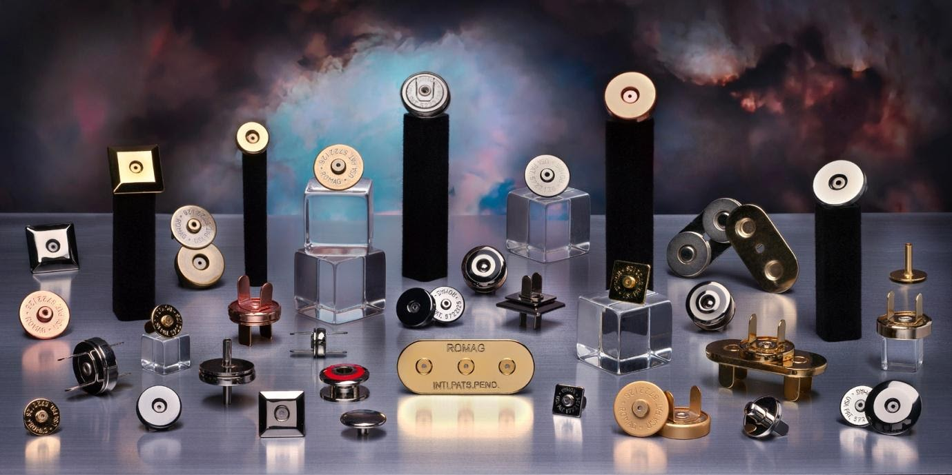
Image Source: https://www.romag.com/


Source- https://www.romag.com/

