“EYE DEW”: A Skin Care Product and an Eye Cream? No Likelihood of Confusion in Non-Identical Products, Rules Ninth Circuit
Or
Want to apply different “EYE DEW” Products on Skin as well as Eye? Go Ahead!
Or
Can Different Cosmetic Products have The Same Mark? Ninth Circuit Answers in Affirmative: Rules no Likelihood of Confusion in Non-Identical Products
Arcona Inc. (“Arcona”) is a company engaged in the manufacturing and production of cosmetic products. Arcona trademarked the term “EYE DEW” for use in its skincare products. Farmacy Beauty, LLC (“Farmacy”) is another company engaged in the same line of business as Arcona. Farmacy through the initial assurance of a copywriter stating that the term “EYE DEW” is available for use started using the term on their cosmetic product line. Arcona came to know of the product and filed a suit for Counterfeiting against Farmacy in the United States District Court of Central District of California (“District Court”) which compared the products as a whole and gave a summary judgment in favor of Farmacy Beauty. The case was appealed by Arcona at The United States Court of Appeals for the Ninth Circuit (“Circuit Court”) (Arcona Inc. v. Farmacy Beauty LLC et al., No. 20-1429) which affirmed the District Court’s grant of summary judgment in favor of Farmacy Beauty, in a trademark counterfeiting action brought by Arcona on account of use of a trademarked term.
In 2015, Arcona registered the term “EYE DEW” for its skincare products. The trademark was for the phrase only without any claim to any particular font, style of writing, color or sizing. Arcona’s product EYE DEW is an eye cream which comes in a tall, cylindrical, silver bottle with a slim cardboard packaging which bears the phrase “EYE DEW” and the house mark of Arcona on both the bottle and the packaging. Whereas, Farmacy Beauty was developing a line of beauty products which included an eye cream which was named “EYE DEW” after a copywriter assured that the disputed name was most likely available based on “an initial online search and uspto.gov trademark lookup.” The product made by Farmacy Beauty was sold in a short, wide, white jar with a “square-ish” outer packaging. This product bears the disputed term and the Farmacy house mark on both the jar and the outer packaging.
Farmacy Beauty received a Cease and Desist notice from Arcona in 2016 informing that the term “EYE DEW” is a trademark belonging to Arcona and asked Farmacy to cease the sale of their infringing product. The record stated that Farmacy had never heard of Arcona and were astonished to receive the notice. The parties then tried to resolve the matter between them personally but that attempt was unsuccessful, following which Arcona sued Farmacy in 2017 alleging “(1) trademark counterfeiting, (2) trademark infringement, (3) unfair competition under Section 43(a) of the Lanham Act, (4) unfair competition under California state law, and (5) unfair competition under California common law.” However, Arcona requested the District court to dismiss the claims of trademark infringement and unfair competition claims.
The District Court gave its judgment in favor of Farmacy Beauty on Arcona’s claim of counterfeiting. The reason that the District Court gave to reach this conclusion was that the only similarity between Arcona’s and Farmacy’s product was the term “EYE DEW.”The District Court also said that Arcona failed to provide any evidence which suggested that people can mistake one product for the other despite the dissimilar packaging and containers. The District Court granted summary judgment on the ground that a reasonable consumer would not confuse Farmacy’s skincare product with Arcona’s because their respective packaging featured different shapes, design schemes, text, and colors.
The matter was appealed before the Circuit Court by Arcona to no avail as the panel of the Circuit Court affirmed the District Courts Judgment. Arcona argued that it need not prove likelihood of confusion to pursue a claim for trademark counterfeiting. The Circuit Court was of the opinion that the preliminary stage for interpreting a statute is the language of the statute itself; the Court mentioned the cases of Consumer Prod Safety Comm’n v. GTE Sylvania, Inc., 447 U.S. 102, 108 (1980) and Sturgeon v. Frost, 136 S. Ct. 1061, 1070 (2016), to buttress the aforementioned point. Under the Lanham Act the section for Trademark Counterfeiting mentions the phrase “likely to cause confusion” and hence is a requirement for an action under the section for a counterfeiting claim. The Court went on to say that section 1114 encompasses both Trademark Infringement and Counterfeiting claims and that this Court repeatedly held that under this section a likelihood of confusion is an essential aspect however that has been done only with relations to Trademark Infringement claims and not Counterfeiting claims. The court said that the statute does not suggest that a claim of Infringement and Counterfeiting have to be judged on different parameters despite being mentioned under the same section. Hence, the likelihood of confusion aspect is present in Counterfeit claims as well.
Further, the panel of the Circuit Court declined to presume confusion because the products stating that they were not identical. The Court mentioned the case of Brookfield Communications, Inc. v. West Coast Entertainment Corp where it was held that “in light of the virtual identity of marks, if they were used with identical products or services, likelihood of confusion would follow as a matter of course.” The Court said that in the present case the products were not at all identical and “identical marks paired with identical goods” is the condition. Hence, the Court cannot presume confusion because the products were not identical.
The panel of the Circuit Court finally held that the District Court judgment was proper as there was no genuine dispute about the likelihood of consumer confusion. Arcona had argued that the District Court was wrong since it did not limit its analysis to the identical marks (“EYE DEW”) and looked at the entire product in assessing consumer confusion. The Circuit Court held that a court should not myopically focus on only the alleged counterfeit marks to the exclusion of the entire product or even common sense. While the products do compete in the same space and same geographic area, there are significant differences between the two products, and the marks should be “considered in their entirety and as they appear in the marketplace. Hence, the District Court had properly compared the products as a whole, instead of limiting analysis to the identical “EYE DEW” marks.
The Circuit Court ruled that to sustain a trademark counterfeiting claim; a plaintiff must show a likelihood of confusion. The two products, when viewed in their entirety, did not remotely resemble each other. The District Court’s decision granting summary judgment for Farmacy was proper and is affirmed.
It is imperative to point out that Arcona has appealed this judgment to the United States Supreme Court where the current matter is pending as of now.
Arcona Inc. v. FarmacyBeauty LLC et al., No. 20-1429

Image to be used:
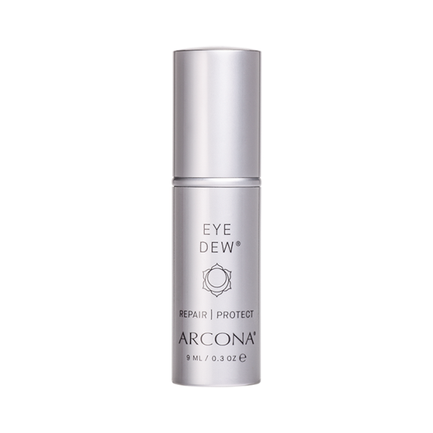
Source- https://www.arcona.com/product/eye-dew.html
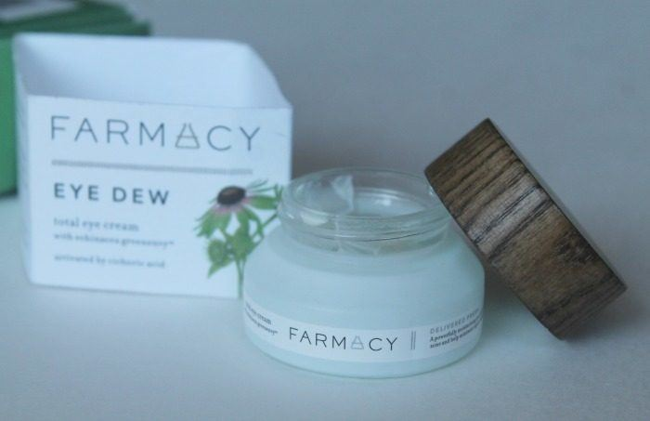
Source- https://makeupandbeauty.com/farmacy-eye-dew-total-eye-cream-review/

