No Proprietary Right required to file Cancellation Claim, Holds Federal Circuit
Or
Fight over “Naked” Mark: No Proprietary Right required for Claiming Cancellation of Mark
Or
“Real interest” is more important than “Proprietary right” for Claiming Cancellation of Mark
Naked TM LLC (“Naked TM”) is a company that sells condoms in the United States. Australian Therapeutic Supplies Pvt. Ltd (“Australian”) is also engaged in the business of selling condoms in the United States. Both the companies sell condoms with the mark “NAKED” on it. This “NAKED” mark was trademarked by Naked TM. Both the companies negotiated via emails and reached a settlement that Australian will not use or register any mark which contained the term “NAKED.” This agreement was not formalized by the parties. Later, Naked TM found out that Australian was still using the “NAKED” mark online. Naked TM sent a notice to Australian to stop using the mark after which Australian went on to file for the cancellation of the “NAKED” trade mark in The Trademark Trial and Appeal Board (TTAB). The TTAB held that Australian had no standing to file for cancellation as the communication between the parties done via emails amounted to an enforceable contract. The matter was appealed to the Federal Circuit Court (“Circuit Court”) (Australian Therapeutic Supplies PTY Ltd v Naked TM, LLC 965 F.3d 1370 (Fed. Cir. 2020)) by Australian. The Circuit Court held that Australian Therapeutic Supplies who had contracted away its rights to an unregistered mark still had a legal standing to move for cancellation of those marks against Naked TM due the reason that Australian still had a “real interest” in the cancellation. Moreover, the Circuit Court denied a petition by Naked TM for an en banc hearing upon this matter.
Australian was engaged in this business through its website since 2003 and sold and advertised its products under the mark “NAKED” which was unregistered. Meanwhile, Naked TM filed for the registration of the mark “NAKED” in 2003. Australian found out about this development in 2005 when Australian proceeded with its first ‘intent-to-use application’ for the mark “NAKED.”
In 2006, both Naked TM and Australian started a negotiation with each other upon this matter through mails. The parties reached an understanding and entered into an “informal” settlement agreement in April 2007 according to which Australian will not use or register any mark which contained the term “NAKED.” This agreement was not formalized by the parties on paper as Australian stated that “there was no need to put anything on paper. Just makes lawyers a lot of money. We no longer have any ‘Naked’ condoms in the USA, so it should be clear sailing for you. Good luck with the launch.” However, the fact that Australian will still continue to sell its “NAKED” condoms in the USA through its website from Australia was not communicated to Naked TM.
In October 2007, Naked’s application for the registration of the “NAKED” mark went through. Following which, Australian cancelled its application for the “NAKED” mark in 2011. The dispute also arose in 2011 when Australian received a mail from Naked TM which said that Australian will have to remove the “NAKED” mark from its Twitter page because it has become a source of confusion. Australian stated its position that “the parties have no agreement in place other than we agreed to co-exist.”
After receiving the mail Australian became hostile and stating prior use filed a petition to cancel the registration of the “NAKED” mark on the grounds of fraud, likelihood of confusion, and false suggestion of a connection. Afterwards Australian amended its petition to include the ground that Naked TM lacked bona fide intent to use the mark. Moreover, Australian went ahead and applied for the registration of the “NAKED” mark again.
The dispute went to The Trademark Trial and Appeal Board (TTAB) which after the hearing held that the communications between the parties which were done through emails amounted to an enforceable contract as a result of which Australian had no standing to request for the cancellation of the registration of the “NAKED” mark.
Australian appealed this decision in the Federal Circuit Court and argued that TTAB was wrong when it said that Australian must have proprietary rights to file a petition for cancellation and that Australian had a real interest in cancellation of the mark and a reasonable belief of damages. Thus, Australian qualifies all the essentials for a cancellation claim.
The majority of the panel of the Circuit Court reversed and remanded the TTAB decision and held that TTAB wrongly required Australian to prove proprietary rights on its unregistered mark in order to ascertain its standing to file a claim for cancellation of the mark. The majority of the panel of the Circuit Court further stated that Australian’s contractual agreement with Naked TM did not bar it from claiming a right to challenge the mark before TTAB. The majority also held that Australian’s contractual agreement did not preclude it from challenging the mark before the TTAB.The Circuit Court said that Australian still had a “real interest” in the cancellation because it filed two applications to register its unregistered mark in the United States, and advertised and sold NAKED condoms in the United States in addition to the fact that Australian’s sales of products that might be found to have infringed the challenged registration also create a real interest and reasonable belief in harm.The court rejected Naked’s argument that the fact that Australian had abandoned its right, demonstrated that there was no harm, instead concluding that Australian’s abandonment of its applications did not create an abandonment of its rights in the unregistered mark.
One of the judges in the Circuit Court dissented, Although he agreed that the TTAB erred by imposing a proprietary-interest requirement, he gave a separate opinion saying Australian lacked a legitimate claim in cancellation of the registered mark due to lack of commercial interest and hence there was no real cause of action against Naked TM. The dissenting judge further said that when the case between the parties has been settled, there is no actual matter in controversy essential to the decision of the particular case and as is the case presently there is “no real controversy between the parties” as they resolved any such controversy between themselves through settlement in 2007 done via mails making Australian “no more than an “intermeddler” in the instant action.
Moreover, Naked TM aggrieved by this decision requested an en banc hearing which was rejected by the Federal Circuit Court. However, the dissenting judge was of the opinion that an en banc hearing is necessary in the present matter.

Australian Therapeutic Supplies PTY Ltd v Naked TM, LLC 965 F.3d 1370 (Fed. Cir. 2020)

Image to be used:
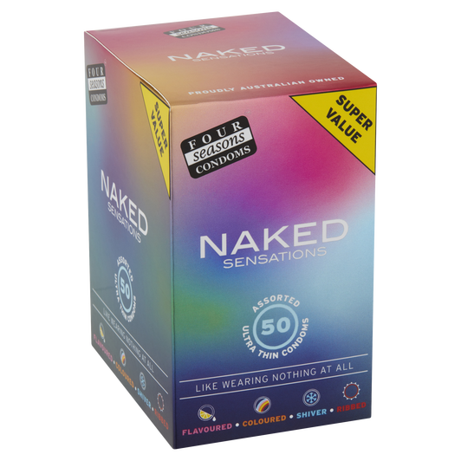

Source- https://www.condoms.com.au/
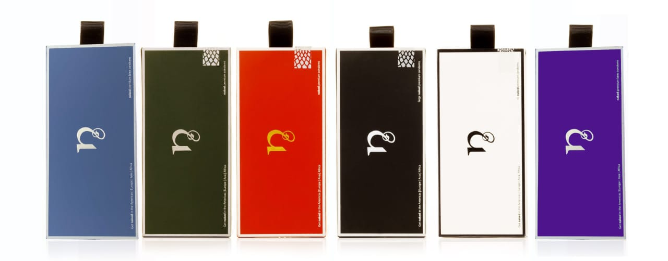
Source- https://nakedcondoms.com/product/luxury-condom/?v=c86ee0d9d7ed

