Black Ice vs. Midnight Black Ice Storm: Too Close for Likelihood of Confusion, Rules Second Circuit
Or
Black Ice is Confusingly Similar to Midnight Black Ice Storm: Rules Second Circuit
Or
Ice is Black; But Only For CFC!

Car-Freshner Corporation and Julius Sämann Ltd. (collectively “CFC”) and American Covers, LLC d/b/a Handstands (“Handstands”), Energizer Holdings, Inc., and Energizer Brands, LLC (collectively, “Energizer”) are in the business of selling car air freshener products, that emit a pleasant scent in automobiles. CFC has a trademark over the word “Black Ice” and “Bayside Breeze.” CFC contends that its trademark has been infringed due to Energizer’s sale of product labeled as “Midnight Black Ice Storm” and “Boardwalk Breeze.” CFC filed a suit against Energizer’s use of the labeled mark in the United States District Court Northern District of New York (“District Court”) (Car Freshner Corp. v. Am. Covers, LLC, 419 F. Supp. 3d 407 (N.D.N.Y. 2019)). However, citing insufficient evidences, the District Court dismissed CFC’s claim that the use of the mark will create a likelihood of confusion as to source of the products. The District Court also rejected the dilution claim citing that the marks are not sufficiently famous. Aggrieved by the District Court decision, CFC appealed to the United States Court Of Appeals for the Second Circuit (“Second Circuit”) (Car Freshner Corp. v. Am. Covers, 980 F.3d 314 (2d Cir. 2020)) which concluded that the record developed by CFC sufficed to withstand Energizer’s motion for summary judgment with respect to the mark “Black Ice” but not its mark “Bayside Breeze.” Therefore, the Second Circuit affirmed in part and reversed in part, the decision of District Court and remanded the case to the District Court for further proceedings consistent with the opinion which Second Circuit observed.
This case entails an unusual context where the allegedly infringing mark uses the same words but adds a word before a word as a prefix.CFC products are marketed under the brand name “Little Trees” since 1952. The product with the mark “Black Ice” include: (1) small two dimensional cardboard pine trees saturated with scented oil, suitable for hanging on a rear-view mirror; (2) vent wraps, a small plastic device that wraps around one of the slats on a car’s interior vents; (3) vent clips, a larger version of a vent wrap that clips onto a car’s interior air vent; (4) an item called “fresh links,” small tear shaped loops that can be hung from the rearview mirror; (5) spray cans; (6) spray pumps; and (7) fiber cans, sealed cans placed under a car seat, opened with a twist-top, containing scented fibers. Products with the mark “Bayside Breeze” include (1) cardboard trees, (2) vent wraps, and (3) fresh links. The air freshener with a scent called “Black Ice” started selling in 2004 and the scents with the name “Bayside Breeze” in 2013.
The scents were successfully marketed, wherein CFC’s net sales of “Black Ice” totaled to tens of millions of dollars annually and “Bayside Breeze” was less than $50,000 in 2013 which increased to around $4,000,000 by late 2018. CFC does not sell these products directly to consumer; rather it sells it to retailers and distributors. The Energizer markets its products under the brand name “Refresh Your Car!” which it acquired from Handstand in 2016. Energizer, too, has a remarkable market base of more than $50 million in total sales annually since 2015. It has a similar structure of marketing as that of CFC, wherein it sells only to retailer and distributor. With its product labeled “Midnight Black Ice Storm” and “Boardwalk Breeze,” the former includes 4- and 6-pack vent sticks, diffusers, mini diffusers, and gel cans while the latter is available only as a 4-pack of vent sticks. The two new products with the labeled name were started by Energizer, after acquiring Handstands in 2016. With the alleged infringement of trademark, Energizer sold more than $1 million of product domestically.
Both the company’s products are sold in the same market and same stores across the United States, including Target, Walmart, Pep Boys, Dollar General, AutoZone, and various supermarkets. The costs of the scents of both the parties are less than $4.00. There were also probable chances that stores selling both the product block the other products so that the product must be surrounded by its own brand. CFC filed a suit in the District Court in 2017 contending the infringement and dilution of the trademarks “Black Ice,” “Bayside Breeze.” The first complaint was for the “Black Ice,” mark, while the amended complaint was for the “Bayside Breeze” mark. After the complaint, Energizer phased out the scent name “Midnight Black” and changed the name to “Lightning Bolt” and stopped selling “Boardwalk Breeze,” as of June 30, 2017.
District Court ruled that the evidences were insufficient to conclude that a reasonable jury might think that the marks of Energize were similar to CFC’s thereby creating a likelihood of confusion. The District Court also rejected the claim of dilution, stating that the mark was not “sufficiently famous.” Finally it granted Energizer’s motion for summary judgment and rejected both of CFC’s claims of infringement and dilution. Aggrieved by this, CFC appealed.
The Second Circuit reviewed the trademark infringement claim through the eight Polaroid factors. The eight Polaroid factors were (i) the strength of the senior user’s marks; (ii) the similarity of the parties’ marks; (iii) the market proximity of their products;5 (iv) the likelihood that the senior user will bridge any gap separating the parties’ current markets; (v) the existence of actual consumer confusion; (vi) whether the junior user acted in bad faith in adopting its mark; (vii) the quality of the junior user’s products; and (viii) the sophistication of the relevant consumer group. While dealing with the Polaroid factors, the Second Circuit put more impetus on two Polaroid factors. They were the second and the sixth i.e. similarity of marks, and bad faith on the part of infringer.
Delving into the first factor, the court noted that “it is extremely unusual for the mark of a junior user to include two identical words of a senior user’s mark in sequence.” This plays an important role when both the parties are competitors in the same market. The Court noted the difference in packaging between the two products but asserted more on findings of trademark infringement. For the bad faith, the court notes the email produced by American Covers revealing that its employees choose product name that forms the connection between American Covers and Car Freshener’s product were “explicit evidence of bad faith.” Therefore, putting weigh on the Polaroid factors, Second Circuit revered the grant of Summary judgment by the District Court on the trademark infringement claims. As to the Dilution Claim of CFC, the Second Circuit affirmed that there is lack of evidence noting that “no evidence supports a finding that either of the marks in question are famous,” as required to claim dilution.

Car Freshner Corp. v. Am. Covers, 980 F.3d 314 (2d Cir. 2020))

Image to be used:
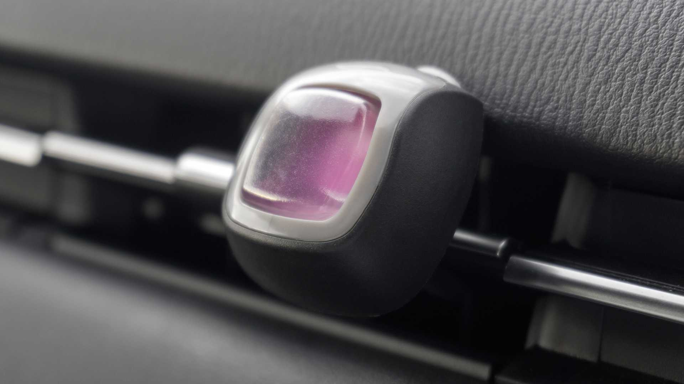
Source: https://www.motor1.com/reviews/410124/best-car-air-fresheners/


Source: https://bcfocus.com/2020-automotive-air-fresheners-market-growth-by-febreze-glade-airwick-yankee-renuzit-lysol-neutra-air-ozium/
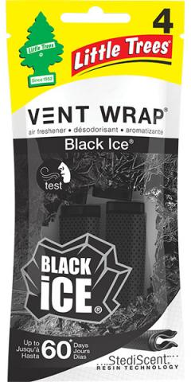

Source- https://www.littletrees.com/fragrances/black-ice

