IONEX vs. Ion-X Glass: No Likelihood of Confusion Owing to Use in Good Faith
Or
“Ion-X” held to be Descriptive in Nature: Use by Apple Inc. in Good Faith, Affirms Second Circuit
Or
Good Faith Use Saves the Day for Apple Inc. in IONEX vs. Ion-X

Saxon Glass Technologies, Inc. (“Saxon”) deals in the work of chemically strengthening glass through a process of ion-exchange. Ion-exchange is "a general scientific term that describes the exchange of one type of ion . . . with another." With its work in the same field, Saxon obtained federal trademark for the mark “IONEX.” Apple Inc. ("Apple") launched its Apple Watch with a glass cover strengthened by ion-exchange, for which Apple uses the term “Ion-X Glass” for describing its ion-exchange strengthened glass. In 2015, Saxon filed a suit at the United States District Court for the Western District of New York (“District Court”) (Saxon Glass Techs., Inc. v. Apple Inc., 393 F. Supp. 3d 270 (W.D.N.Y. 2019) alleging trademark infringement based on likelihood of confusion between its IONEX mark and Apple's use of the term Ion-X. Apple move for the summary judgment asserted that the use of the mark is fair-use and there is no likelihood of confusion. District Court granted summary judgment in favor of Apple. Aggrieved by this, Saxon appealed to the United States Court Of Appeals for the Second Circuit (“Second Circuit”) (Saxon Glass Techs., Inc. v. Apple Inc., 19-2190-cv (2d Cir. Sep. 11, 2020)). Agreeing with the District Court ruling, the Second Circuit affirmed with the District Court and granted the judgment in favor of Apple.
The trademark obtained by Saxon was in compliance with the goods/services it provides with respect to the chemical treatment of glass. The service it provides is primarily for its businesses. Saxon is the primary provider of glass-strengthening for Gerresheimer Glass Inc. ("Gerresheimer"). For companies, like Samsung Display and Nippon Electric Glass, Saxon has provided research and development ("R&D") services. Nevertheless, the services it provided to Gerresheimer for their products have actually been released in the market. The selling of Apple Watches with the term "Ion-X Glass" describes ion exchange strengthened glass, with the term appearing on the back of the watches. The term is also visible on the packaging boxes consisting a description such as "Composite Black" and "7000 Series Aluminum." On the Apple’s website, the term is visible explaining that the glass is "fortified at the molecular level through ion-exchange," with the appearance of Apple logo appearing near the term "Ion-X." Nevertheless, it has to be noted that Apple has not applied for the trademark of the term at the United States Patent and Trademark Office (“USPTO”), thereby not including it in the list of trademark.
Alleging trademark infringement, Saxon filed a suit in the District Court against Apple. It alleged that the infringement is based on likelihood of confusion between its IONEX mark and Apple's use of the term Ion-X. Saxon characterized that as a trademark “substantially similar in sound, appearance and connotation” to its own, and one that would confuse consumers. Apple contended that (1) its use of Ion-X constituted fair use and (2) Saxon is unable to show likelihood of confusion between the marks, and thereby it moved for summary judgment. Delving into both the ground, District Court granted summary judgment favoring Apple. District Court viewed that the usage of the mark “Ion-X” is primarily descriptive in nature and a reasonable jury could only have found such use as merely descriptive. Apple is not using the mark as a trademark but, rather, used it in its "descriptive sense" and in good faith. Moreover, the District Court concluded that there was no such likelihood of confusion that a reasonable jury could find and therefore agreed to Apple’s motion of summary judgment.
The applicable law in this case will be Section 43(a) of the Lanham Act which prohibits the use in commerce of "any word, term, name, symbol, or device" that "is likely to cause confusion . . . as to the origin, sponsorship or approval" of goods or services. The plaintiff needs to prove that (1) it owns a "protectable trademark" and (2) the defendant's mark "is likely to confuse consumers as to the source of the product. Moreover for determining the likelihood of confusion, the eight factor test needs to be complied which was set forth in Polaroid Corp. v. Polarad Elecs. Corp., 287 F.2d 492 (2d Cir. 1961). The test were 1) strength of the trademark; (2) similarity of the marks; (3) proximity of the products and their competitiveness with one another; (4) evidence that the senior user may 'bridge the gap' by developing a product for sale in the market of the alleged infringer's product; (5) evidence of actual consumer confusion; (6) evidence that the imitative mark was adopted in bad faith; (7) respective quality of the products; and (8) sophistication of consumers in the relevant market.
The Second Circuit affirmed with the District Court that Saxon was unable to prove the likelihood of confusion. Referring to Sunmark, Inc. v. Ocean Spray Cranberries, Inc., 64 F.3d 1055, 1059 (7th Cir. 1995), it noted that the hyphenated word and acronyms can be considered descriptive for the purpose of fair use. Second Circuit, weighing the Polaroid factors, was in affirmation that the first four Polaroid Factors weighed in favor of Apple. On evaluating the fifth factor of actual confusion, District Court relied that this factor is “neutral” and weighed in favor of neither party which was affirmed by the Second Circuit. As to the sixth factor, Saxon was not able to prove that Apple acted in bad faith. Since, Saxon only appealed on the first six factors, Second Circuit did not delved into the other two factors. Moreover, the Second Circuit also agreed that Saxon’s mark is commercially and conceptually weak because it is a descriptive term through which Saxon strengthens glass. Even when Apple uses the mark with its own brand, the consumer can identify the watch as an Apple branded watch. The businesses of both the companies are also different wherein Saxon deals in glass strengthening services for businesses, whereas Apple sells electronic products directly to consumer. Considering all these factors, Second Circuit affirmed the District Court judgment of granting Apple’s motion for summary judgment.
Saxon Glass Techs., Inc. v. Apple Inc., 19-2190-cv (2d Cir. Sep. 11, 2020

Image to be used:
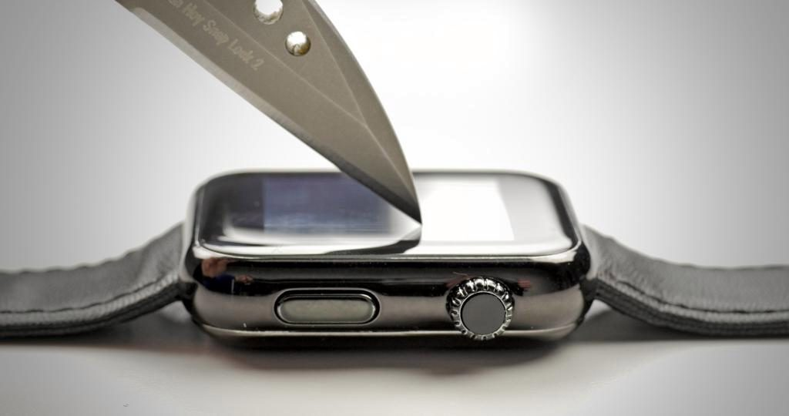
Source- https://9to5mac.com/2015/04/21/apple-watch-sport-ion-x-glass-scratch-test-video/

